Q1. Importance of EIA in engineering project.

* Promotes better planning and leads to more responsible decision making; ensures that renewable and non-renewable resources are used wisely
* Evaluates the rationale behind proposed projects and activities; are there alternatives to a proposed project or activity?
* Assists in pursuing sustainable development by evaluating alternatives means of undertaking proposed projects and activities
* Helps to identify and understand **environmental** impacts early in the project cycle; predicted impacts can be mitigated before they occur
* Provides opportunity for input from interested parties; increases likelihood of public acceptance

Q2. To know importance of baseline the information before starting EIA study

* Measure impact on the project

Q3. Proposition of negative impacts of a proposed projects and its mitigation

Negative impact and its mitigation for the project of mining of minerals

1. Land Environment

Anticipated Impacts:

* Impact on topography, drainage pattern, land use with respect to agriculture, forestry, built-up area etc.
* Impact on soil quality and agriculture
* Soil erosion
* Subsidence
* Visual Impact on surrounding environment

Mitigation Measures:

* Plan for restoration/rehabilitation of mined-out area
* Technological measures to prevent soil erosion from core and buffer zones
* Plantation/afforestation of local varieties of plants
* Measures to control and conserve runoff from various locations.
* Landscaping, plantation, afforestation to minimize adverse visual and noise impact

2.Air Environment

Anticipated Impacts:

* Emission Inventory of SPM, RSPM, SO2, NOX, and site specific pollutants
* Prediction of fugitive dust emissions due to mining activities, crushing and cleaning plants, loading and unloading, transportation by rail, road or conveyor.
* Impact of fugitive dust emission on flora and fauna Prediction of impact on ambient air quality using appropriate mathematical model (area, point and line sources). Description of model, input requirements and reference of derivation. Isopleths distribution of major pollutants and their analysis and presentation in tabular form/base map.

Mitigation Measures:

* Measures to reduce the emissions of pollutants during mining, loading, unloading, transportation, drilling, blasting, crushing etc to maintain the air quality
* Adoption scientific mining methods to reduce dust emission from point and line source
* Planned green belt development

3.Water Environment (surface and groundwater)

Anticipated Impacts:

* Impact on groundwater regime/streams / lake / springs due to mining, to be assessed from hydro-geological study
* Impact of water drawl(inflection) on surface and groundwater resources
* Impact on surface and groundwater quality due to discharges from mining, tailings pond, workshop, township, leachate from solid waste dumps etc.
* Ingress of sea water, particularly for mining projects in coastal areas.

Mitigation Measures:

* Measures to minimize contamination of surface and groundwater
* Construction of gully checks, check dams, sedimentation ponds, settling tanks, water weirs, retaining walls etc. with design and site features for control of run-off
* Mine water treatment for meeting the prescribed standard
* Slope stabilization by constructing retaining walls, vegetation etc.
* Steps to minimize impact on water table if mining intercepts groundwater regime.
* Wastewater treatment for township sewage, workshop(s), tailing pond overflow etc.

4. Noise Environment

Anticipated Impacts:

* Prediction of noise level by using mathematical modeling at different representative monitoring stations
* Impact of vibrations including damage to materials/structures due to blasting
* Impact on ambient noise level due to rock excavation, transportation, processing equipment and ancilliaries.

Mitigation Measures:

* Measures for noise abatement including point source and line source
* Measures to minimize effect by blasting
* Lay out planning to minimize the impact on receiving environment
* Planned preventive maintenance
* Selection of low noise equipment failing which use of retrofit for existing equipment

5. Biological

Anticipated Impacts (Flora and Fauna):

* Impact on forest resources, economically important plants, medicinal plants and threat to rare, endemic and endangered species
* Impact on terrestrial and aquatic biodiversity
* Impact on wildlife including avi-fauna
* Impact on wildlife habitat and migratory corridors
* Impact on flora and fauna due to air emissions, noise, vibration, illumination, vehicular movement, waste water discharges, changes in land use, township etc.

Mitigation Measures:

* Measures to compensate the loss of forest coverage
* Regeneration of rare and endangered plants of economic importance including medicinal plants.
* Measures for protection and conservation of wildlife species
* Green belt and its raising schedule
* Progressive afforestation in overburden, reclaimed mined out areas

6. Socio- Economic Environment

Anticipated Impacts:

* Displacement of human settlements during the life of the mine
* Positive and negative impacts on present status of livelihood in the area
* Impact on the cropping pattern and crop productivity in the buffer zone
* Impact on community resources such as grazing land

Mitigation Measures:

* Rehabilitation and resettlement of land oustees and displaced people
* Compensation for loss of land and crops
* Training to locals for employment in the project
* Employment opportunities and access to other amenities such as education, health care facilities to be extended to locals

7. Mine Wastes

Anticipated Impacts:

* Impact of runoff from overburden, top soil, low-grade ore and other stock piles on water bodies (siltation, contamination etc)
* Loss of vegetation and wildlife habitat
* Impact on surrounding agricultural land
* Impact on groundwater quality due to leachate
* Sliding of waste dump
* Impact of hazardous wastes and liquids

Mitigation Measures:

* Land reclamation and mine closure plan
* Overburden dumps stabilization to minimize impact due to runoff
* Overburden utilization for back-filling and other purposes. Simulation model with 5 years projection with digitized maps
* Municipal solid waste management in township
* Measures to control runoff from waste dumps and mining surface.
* Hazardous waste management as per regulatory guidelines

Q4. Economic benefits of productivity EIA for the country

* A healthier local environment (forests, water sources, agricultural potential, recreational potential, aesthetic values, and clean living in urban areas)
* Improved human health
* Maintenance of biodiversity
* Decreased resource use
* Fewer conflicts over natural resource use
* Increased community skills, knowledge and pride

Q5. Importance of public participation in EIA study

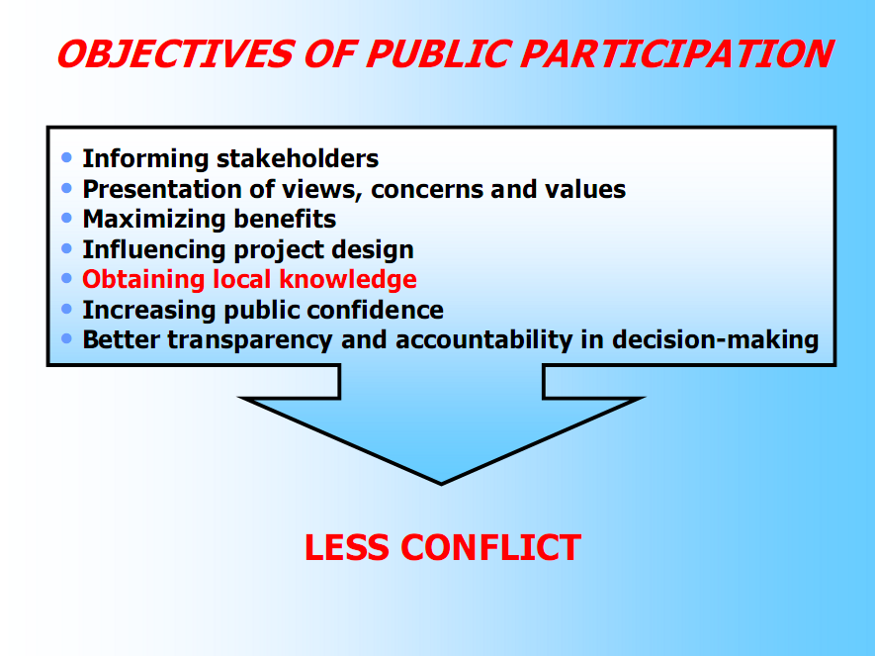

Q6. Process for conducting EIA study

* + **screening -** to determine whether or not a proposal requires a full-scale and the level at which this assessment should occur
  + **scoping -** to identify the important issues and prepare terms of reference
  + **impact analysis -** to predict the effects of a proposal and evaluate their significance
  + **mitigation -** to establish measures to prevent, reduce or compensate for impacts
  + **reporting -** to prepare the information necessary for decision-making
  + **review -** to check the quality of the EIA report
  + **decision-making – (**to approve or reject) the proposal and set conditions
  + **follow up -** to monitor, manage and audit impacts of project implementation
  + **public involvement -** to inform and consult with stakeholders

**Q7.** Terms of references

* objectives and background to the proposal
* study area and boundaries
* alternatives to be examined
* opportunities for public involvement
* impacts and issues to be studied
* the approach to be taken
* requirements for mitigation and monitoring
* information and data to be included in the EIA report
* timetable and requirements for completion of the EIA process